# **An Irish Airman Foresees his Death by William Butler Yeats: Summary and Analysis**

The poem is a short dramatic monologue, a crisp, concise and thrilling soliloquy of its hero, a volunteer Irish airman, Major Robert Gregory, who was killed in action on the Italian front on January 23, 1918. It is originally one of four poems written by William Butler Yeats to honor the death of Major Robert Gregory, son of Lady Augusta Gregory.

Actually, he was accidentally shot down by an Italian pilot, not by an enemy airman. The poem is not an implicit lament for a personal friend, but the presentation of Robert Gregory, who speaks as a prototype fulfilling everything which Yeats most admired.

The speaker, an Irish airman (Robert Gregory) fighting in World War I, who is still confused with the reason for fighting. He possessed psychic second sight which gave him intuition of his death, states that he knows he will die fighting among the clouds. He clarifies the reason for fighting is not a political one, nor the patriotic feeling to England, nor the hatred for the Germans. It was rather ‘a lonely impulse of delight’. Though the reason is not clear to him, he is sure that he will face death during this war any time either by the enemy force or by mechanical error. This was an astonishing view for First World War times, when most young Englishmen thought it their duty to die for their country. Gregory's roots were specifically in his demesne at Kiltartan, where he realized the poor would not benefit, whether the war was lost or won. Here he realizes the fruitlessness of his participation in the war and at the same time he also foresees the futility of war. The life of his people remain unaffected by the result of the war. He further states that he weighed his life and found that his earlier life was a great waste and the upcoming future is also forecasted as a waste of time. As death is inevitable, he made his decision to join the aircraft army with cold, dispassionate bravery, knowing the consequences.

It is a magnificent, short poem, showing Yeats's development as a poet in verse absolutely suitable to his living in the Ireland of his day, rather than in any Celtic dream world. A strong statement is secured by the many rhetorical repetitions:

The four-footed lines, nearly all end stopped with tight rhymes, give the poem an inevitable finality, like death itself; and as two-thirds of the words are monosyllabic, this proud simplicity makes it hang in the memory. The poem is equally divided into two eight-line sentences with four iambic tetrameter stanzas. Yeats writes in the first person persona of the airman while he is going to fight in the sky.

Analysis

“An Irish Airman Foresees His Death” is a short dramatic monologue, originally one of four poems written by [William Butler Yeats](https://www.enotes.com/topics/william-butler-yeats?en_action=content_body_click&en_label=%2Ftopics%2Fan-irish-airman-foresees-his-death&en_category=internal_campaign) to commemorate the death of Major Robert Gregory, son of Lady Augusta Gregory (Yeats’s onetime patron and later his colleague). Gregory, never a close personal friend of Yeats, was a multitalented Renaissance man, titled Irish gentry, athlete, aviator, scholar, and artist who, even though over the age for compulsory military service, enlisted in World War I. He did so because it was a magnificent avenue for adventure.

The poem is equally divided into two eight-line sentences with four iambic tetrameter quatrains. Yeats writes in the first person, donning the persona of the airman as he prepares to go into battle in the sky. In the first quatrain, Yeats shows the airman’s ambiguous feelings about fighting in the war; he has no strong emotions concerning either those he is fighting against or those he is fighting to protect. Even with these mixed sentiments, however, he is sure that he will die in this adventure. Not only is death from enemy contact possible but also, with aviation in its infancy, the chances for mechanical error multiply the dangers he faces.

The second quatrain continues this ambiguity as the airman realizes the fruitlessness of his participation in the war. He knows that no matter what the outcome of his personal battles, they will not affect the overall war effort—nor will the outcome of the war affect the lives of the Irish peasants with whom he identifies.

The third quatrain indicates the selfish desire for adventure that was the airman’s reason for enlisting to fight. His rugged individualism made his choice preordained; only his method of fighting was open. True to a romantic tradition, the airman chose the imagined “chivalry” of single combat in the rarefied heavens over the anonymity of the wholesale slaughter which the ground soldier confronted on the battlefield when faced with the advancements of modern warfare. Gone were the traditional concepts of bravery and honor; the arbitrariness of artillery, machine-gun fire, and poison gas killed randomly.

In the final line of the last quatrain, Yeats leaves the first person when he says, “In balance with this life, this death.” Particular attention should be paid to Yeats’s shift to “this” life, “this” death as opposed to using “my.” He is universalizing the airman’s experiences, transcending the politics of World War I and moving to the realization of the futility of all wars, all waste of human life.

Throughout the poem, the airman feels no sense of disappointment, no misgivings about his fate, no disillusionment about his outcome. He has accepted the challenge in the tradition of the romantic hero and will continue on toward his preordained end.

Themes and Meanings

In “An Irish Airman Foresees His Death,” Yeats uses the dramatic monologue to accomplish a dual purpose. Yeats is using the death of an Irish hero to further the prestige of Irish nationalism; Gregory was well-suited for the purpose. He was of the nobility; he was a volunteer in the truest sense of the word; he was a worldly, sophisticated Renaissance man; he was a war hero (recipient of the Military Cross); and he was an Irish patriot. No matter what the true reason Gregory chose to fight in World War I, he was an ideal vehicle for Yeats’s propaganda.

Several ironic facts may be noted about Gregory’s death and about the possible influence that he may have had (if his life had continued) on both the public and private sphere. Gregory was accidentally shot down by an Allied war plane, a fact that Yeats did not know at the time he composed this poem. Gregory also had been active in Irish politics prior to his enlistment. After the war, England sent in the hated Black and Tans to enforce order in Ireland. Because of Gregory’s prestige and power, he may have been able to exert some mollifying control over the chain of events that immediately followed the armistice. His death also led his impoverished wife to sell his ancestral home, Coole, because she was unable to manage the estate.

Yeats’s second purpose is to explore the futility of war and the waste of human life that results. The airman balances his past life and his future, and decides that they are equally wasteful. War will have no effect either on him or on the populace for whom the war is supposedly being fought. The banality of the situation is that the airman is able to see this and is able to ignore the emotional pleas that are normally used to entice men to fight. Yeats was confronted with a complex problem. The traditional language of poetry was of no use in conveying the ghastly horrors of modern trench warfare. Many poets, such as Siegfried Sassoon, Wilfred Owen, and Edward Thomas, developed a new language and form to meet these new demands. For Yeats, an escape back to the traditional romantic hero allowed him to voice his own poignant protest in a world gone mad.

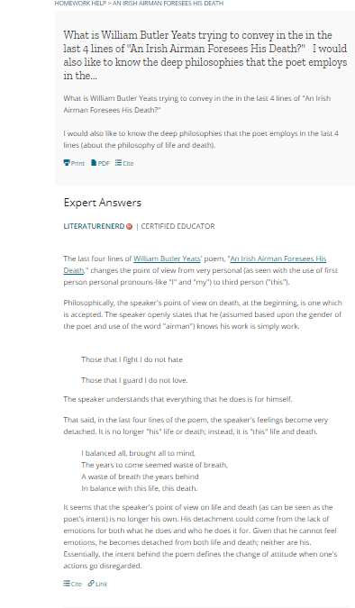

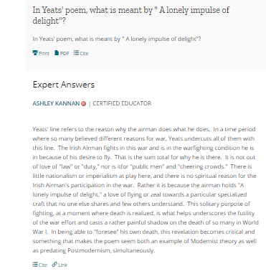

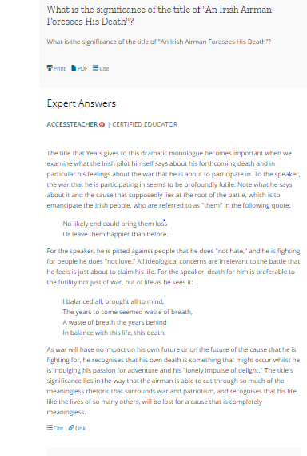

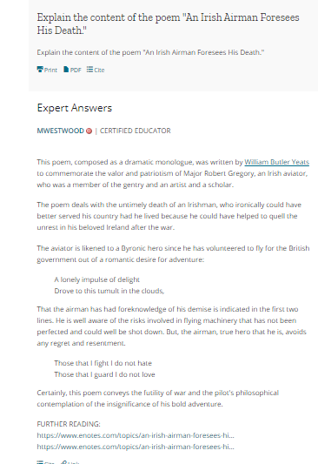

A Painful Case

Summary:

Middle-aged and solitary, [Mr. James Duffy](https://www.gradesaver.com/dubliners/study-guide/character-list#mr-james-duffy) lives in a house in Chapelizod, a suburb of Dublin. His home is small and orderly. The narrator describes the place in some detail. There are books ordered on the shelves according to bulk, simple and completely functional pieces of furniture, and a well-ordered desk.

His days are run by a schedule, and the schedule is always the same. He has a well-paying job at a bank. He comes in the morning by tram; eats lunch at Dan Burke's; leaves work at four; takes dinner at an eating-house on George's street, where fashionable young people will not bother him; and spends his evenings either in front of his landlady's piano or out to enjoy a Mozart opera or concert. He is not a churchgoer, and he has no friends. He sees his family only at Christmas and funerals.

One evening in the rotunda, he is at a thinly attended concert when the woman next to him makes a casual comment about the unfortunately small audience. She has an intelligent, attractive face, with eyes revealing a sensible nature. He takes her comment as an invitation to talk, and they do. She is with her daughter. A few weeks later, he sees her again. He tries to strike up a more intimate conversation while the daughter is distracted. The woman, whose name is Mrs. Emily Sinico, has mentioned her husband. Mr. Duffy and [Mrs. Sinico](https://www.gradesaver.com/dubliners/study-guide/character-list#mrs-sinico) meet a third time by accident, and this time Mr. Duffy is bold enough to invite her to meet with him again sometime. They begin to see each other regularly, always in the evening and in rather obscure neighborhoods. Mr. Duffy, who doesn't like the secrecy of these meetings, insists on seeing her at her own home. Captain Sinico is always traveling on business, but he encourages the visits because he thinks Mr. Duffy is interested in his daughter. The idea of his wife being attractive or desirable never occurs to him.

Mr. Duffy shares his ideas with her, and she opens up to him. He loans her books and music. They become very close. He tells her of his former experiences with the Irish Socialist party; the meetings did not appeal to him, as the other men were all workers with very practical concerns. When the party divided, he stopped going to meetings. No revolution in thinking would come of these men; their concerns were too pragmatic to change the world. She asks Mr. Duffy why he doesn't write out his thoughts, and he scorns the idea; recognition from the un rigorous and conventional-minded masses means nothing to him.

They spend more and more time alone together, including evenings at her college. They speak of personal matters. One night, when speaking of the individual's insurmountable loneliness, she takes his hand passionately and presses it to her cheek. Mr. Duffy is surprised; she has misunderstood. He does not see her for a week, and then sends word asking to meet her. The meet in a cakeshop near the Parkgate, and then walk in Phoenix Park for three hours. They agree that they cannot meet again.

His life continues in its orderly fashion. He reads some Nietzsche and avoids concerts, for fear of seeing her. Life goes on. Finally, one night when his is out dining he is reading the paper when he sees something that stops him. He reads the same piece again and again, unable to eat; he tries to finish his meal, but must stop after a few mouthfuls. When he goes home that night, he reads the paper again. It is an article about the death of Mrs. Sinico. She was struck accidentally by a train; evidence suggests that she was drunk. Her daughter Mary reveals that lately Mrs. Sinico often drank at night.

Mr. Duffy is at first disgusted by the story; she seems to him crude and degraded for having fallen into drink and having died in such an undignified manner. Then the memory of her hand touching his hits him, and he goes out to the pub at Chapelizod Bridge. He drinks there for a while, becoming more ill at ease. He struggles with the two images he now has of her: the lonely drunkard and the charming woman he became close to. He wonders if he could have done more for her. He goes out on a walk, even though it is biting cold.

He thinks of her lonely life, and his, which will simply continue in the same routine until he dies. As he walks, he almost believes that she is there with him; it seems as if his memory is so strong that he can hear her voice, or feel her hand. From a hill, he looks down at the wall of the park, where he sees lovers lying. He feels outcast from human life. He knows the lovers are aware of his presence and want him to leave; so they, too, reject him. He hears a train. The engine seems to be repeating her name.

He stops to rest under a tree until the rhythm fades. But then he can no longer hear her voice or feel her presence. All is silent: he is completely alone.

Analysis:

"A Painful Case" is another story dealing with isolation. Yet another failed or distorted love story, Joyce uses allusion to make his own tale more biting. The site of the affair, Phoenix park, was the supposed location for parts of the tale of Tristram and Iseult, the passionate but doomed lovers of Arthurian legend. Tristram and Iseult were legendary for their passion, and were two beautiful people in the prime of life. Joyce juxtaposes this background to Mr. Duffy and Mrs. Sinico, middle-aged and participating in an entirely sexless affair.

Mr. Duffy's imprisonment is self-imposed. He is terrifyingly alone and isolated, but he has chosen this life for himself. He is also prudish, as we can see in his treatment of Mrs. Sinico. Duffy lacks the courage or imagination to pursue happiness with Mrs. Sinico, despite the fact that both people are clearly dissatisfied with their current situations. However, Mr. Duffy does not realize the extent of his loneliness until it is too late.

One of his great failures is his basic lack of empathy, as seen in his experience with the socialist group. He is more concerned with abstractions than wages, and he cannot seem to empathize on a meaningful level with the workers in the group. Later, his cold treatment of Mrs. Sinico stems from this same shortage of empathy.

The story of Mrs. Sinico's death is the catalyst for Mr. Duffy's revelation. The circumstances surrounding her demise seem to suggest that suicide was a possibility, although Mrs. Sinico may merely have been drunk. The coroner's report indicated that she was taken completely by surprise and died of shock, although one could argue that a moving tram comes as a surprise even when one has stepped in front of it intentionally. The story's climax, as with many other stories in Dubliners, is the protagonist's epiphany. Once her presence leaves him, he realizes that he is alone, that he has been alone all along, and that he will always be alone.